Visualizing and Predicting Heart Diseases with an Interactive Dashboard

**NALAIYA THIRAN PROJECT REPORT**

# 2022

***Submitted by***

|  |  |
| --- | --- |
| **YOGARAJ S** | **714219104014** |
| **LEANDER FELIX P** | **714219104007** |
| **UTCHIMAKALI M** | **714219104011** |
| **RAGHUL K A** | **714219104008** |

**Team ID: PNT2022TMID43181**

**Content**

1. **INTRODUCTION**
   1. Project Overview
   2. Purpose
2. **LITERATURE SURVEY**
   1. Existing problem
   2. References
   3. Problem Statement Definition
3. **IDEATION & PROPOSED SOLUTION**
   1. Empathy Map Canvas
   2. Ideation & Brainstorming
   3. Proposed Solution
   4. Problem Solution fit
4. **REQUIREMENT ANALYSIS**
   1. Functional requirement
   2. Non-Functional requirements
5. **PROJECT DESIGN**
   1. Data Flow Diagrams
   2. Solution & Technical Architecture
   3. User Stories
6. **PROJECT PLANNING & SCHEDULING**
   1. Sprint Planning & Estimation
   2. Sprint Delivery Schedule
   3. Reports from JIRA
7. **CODING & SOLUTIONING (Explain the features added in the project along with code)**
   1. Feature 1
   2. Feature 2
8. **TESTING**
   1. Test Cases
   2. User Acceptance Testing
9. **RESULTS**
   1. Performance Metrics
10. **ADVANTAGES & DISADVANTAGES**
11. **CONCLUSION**
12. **FUTURE SCOPE**
13. **APPENDIX**

Source Code

GitHub & Project Demo Link

# TEAM ID : PNT2022TMID033843

**VISUALIZING AND PREDICTING HEART DISEASES WITH AN INTERACTIVE DASHBOARD**

# Introduction

## Project Overview

The leading cause of death in the developed world is heart disease. Therefore, there needs to be work done to help prevent the risks of having a heart attack or stroke. This project aims to create an interactive Dashboard using IBM Cognos Tool and dataset to predict which patients are most likely to suffer from a heart disease in the near future using the features given.

## Purpose

Heart disease (HD) is a major cause of mortality in modern society. Medical diagnosis is an extremely important but complicated task that should be performed accurately and efficiently. Cardiovascular disease is difficult to detect due to several risk factors, including high blood pressure, cholesterol, and an abnormal pulse rate. Based on the analytics we can analyze which patients are most likely to suffer from heart disease in the near future and based on the patient details we will make decisions to cure them.

# Literature Survey

## Existing Problem

Even though we have smart watches that constantly monitor various aspects like heart rate, oxygen levels, etc but it doesn't give us any conclusive results on the person's health. We also have applications that give ECG from smart watches.

Heart Disease is a complicated disease which is caused by a lot of attributes. Even though devices give us a lot of data we need to compare, analyze and interpret them to make it useful.

## References

**B. Dun, E. Wang, and S. Majumder, "Heart disease diagnosis on medical data using ensemble learning," 2016.**

Deep learning, which belongs to a larger family of machine learning techniques, has the ability to effectively examine a lot of data. In this, overview of these machine learning techniques that may be used to improve the functionality and intelligence of an application. Determining the fundamentals of various machine learning approaches and how they can be used in a variety of real-world application areas, including cybersecurity systems, smart cities, healthcare, e- commerce, agriculture, and many more, is thus the core contribution of this work. We also discuss the difficulties and potential possibilities for future research based on our findings. Overall, this work seeks to serve as a resource for decision- makers in a range of practical scenarios and applications, including those in academia and industry.

**ADVANTAGES**

It is used to diagnose various cardiac diseases.this paper proposes a method of detecting

arrhythmia using the raw ECG signal.

**DISADVANTAGES**

Poor Ability To Charcuterie Arrhythmic Events.Low diagnostic yield.

## F. Yaghouby, F. Yaghouby, A. Ayatollahi, and R. Soleimani,"Classification of cardiac abnormalities using reduced features”.

In this study, a clinical decision support system (CDSS) that analyzes patients with heart failure (HF) and generates a variety of outputs, including an assessment of the severity of the HF, a prediction of the type of HF, and a management interface that contrasts the follow-ups of the various patients. The entire system is made up of an intelligent core component and an HF special-purpose management tool that also serves as an interface for training and using artificial intelligence. A machine learning strategy to put the smart intelligent functions into practice.

World Health Organization, Cardiovascular Diseases, WHO, Geneva, Switzerland, 2020.

By applying different machine learning algorithms and then using deep learning to see what difference comes when it is applied to the data, three approaches were used. In the first approach, normal dataset which is acquired is directly used for classification, and in the second approach, the data with feature selection are taken care of and there is no outliers detection.

**ADVANTAGES**

Improvements that could be explored to improve the scalability and accuracy of this prediction

system.

**DISADVANTAGES**

The dimensional of the heart database is high, so identification and selection of significant

attributes for better diagnosis of heart disease are very challenging tasks .

## American Heart Association, Classes of Heart Failure, American Heart Association, Chicago, IL, USA, 2020.

By providing more reliable and consistent techniques for the detection, classification, reconstruction, denoising, quantification, and segmentation of patterns in biomedical pictures, deep learning and machine learning have made significant advances in the field of biomedical image analysis.

**ADVANTAGES**

Quickly process large amount of data. It is scalable.

**DISADVANTAGES**

For better accuracy local is required.

## Problem Statement Definition

In India in 2016, CVDs (Cardiovascular Diseases) contributed to 28·1% of total deaths and 14·1% of total disability-adjusted life years (DALYs). Most persons with coronary heart disease

who pass away are 65 years of age or older. Although both sexes can get heart attacks in old age, women have a higher mortality rate (within a few weeks). Risk for heart disease can be increased by a number of medical issues, lifestyle, age, and family history. When a person is affected by heart disease, it causes side effects. Chest pain, chest tightness, chest pressure and chest discomfort Breathing difficulties, Neck, jaw, throat, upper abdomen, or back pain. Heart disease - and the conditions that lead to it - can happen at any age. High rates of obesity and high blood pressure among younger people (ages 35–64) are putting them at risk for heart disease earlier in life. CAD happens when coronary arteries struggle to supply the heart with enough blood, oxygen and nutrients. Cholesterol deposits, or plaques, are almost always to blame. These buildups narrow your arteries, decreasing blood flow to your heart. This can cause chest pain, shortness of breath or even a heart attack.

Therefore in order Predict if the patient suffers from heart disease- The health professional enters the input values from the patient's health report. The data is fed into the project model which predicts the probability of having heart disease.

# Ideation and Proposed Solution

## Empathy Map Canvas

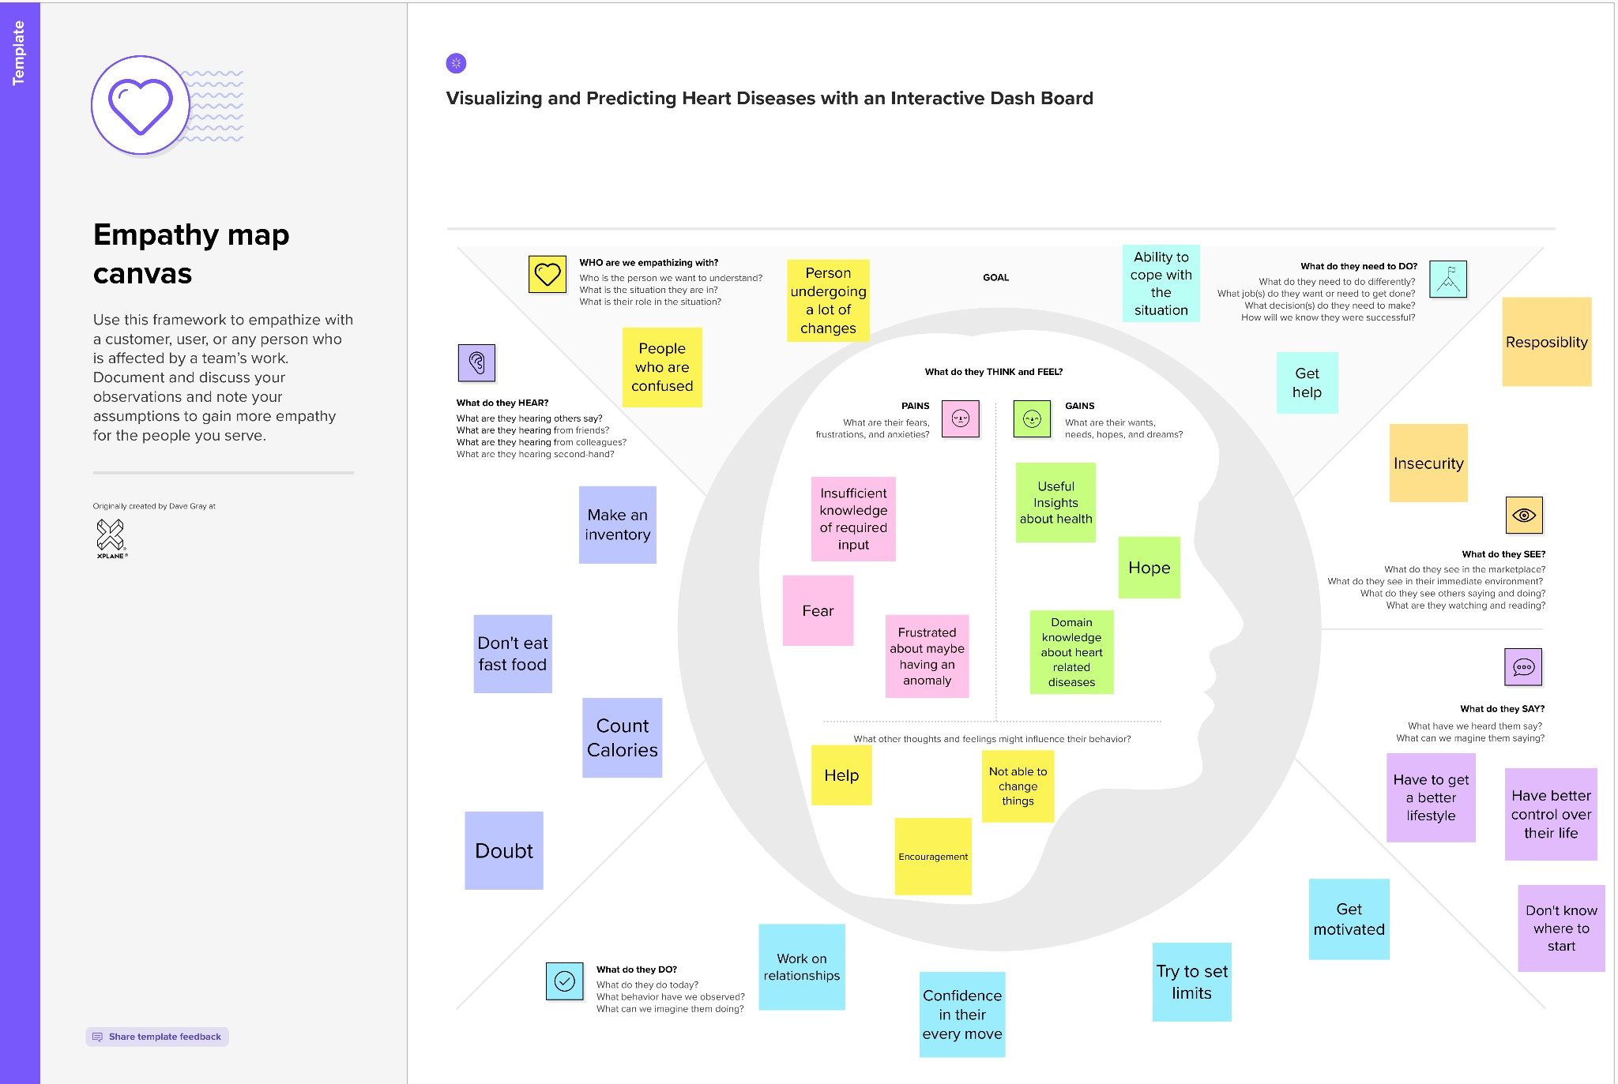

* 1. **Ideation and Brainstorming**

Step-1: Team Gathering, Collaboration and Select the Problem Statement

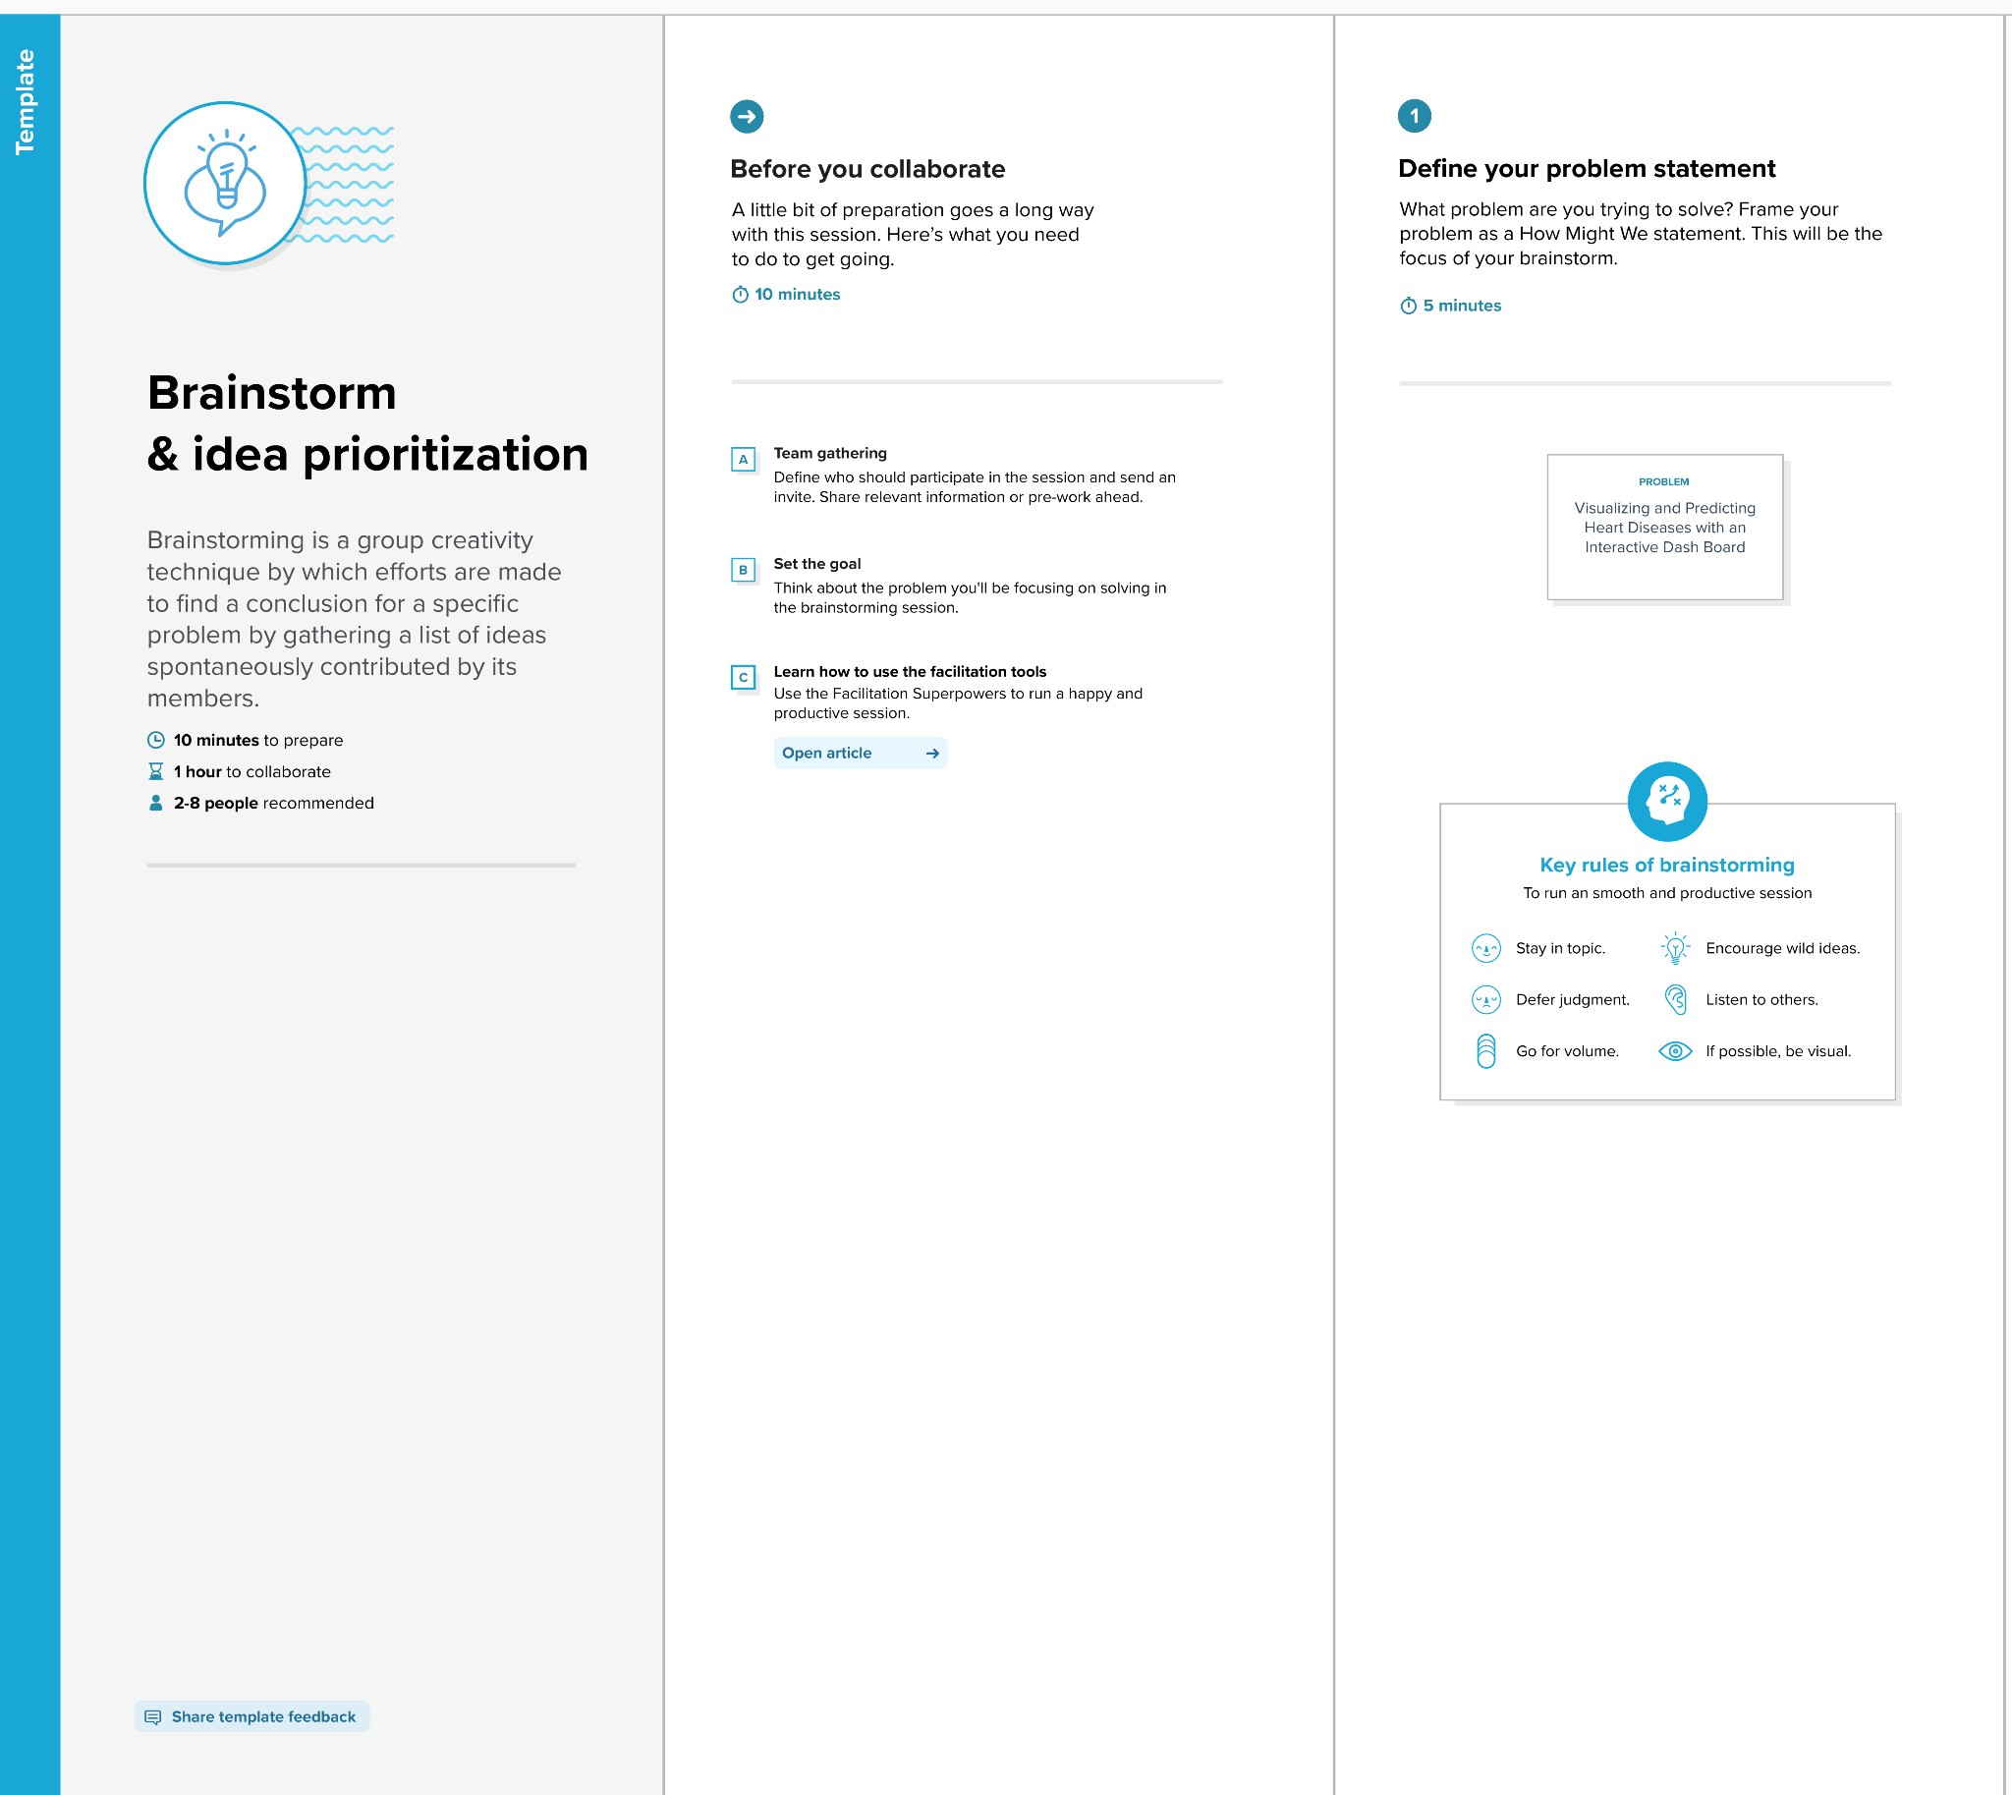

Step-2: Brainstorm, Idea Listing and Grouping

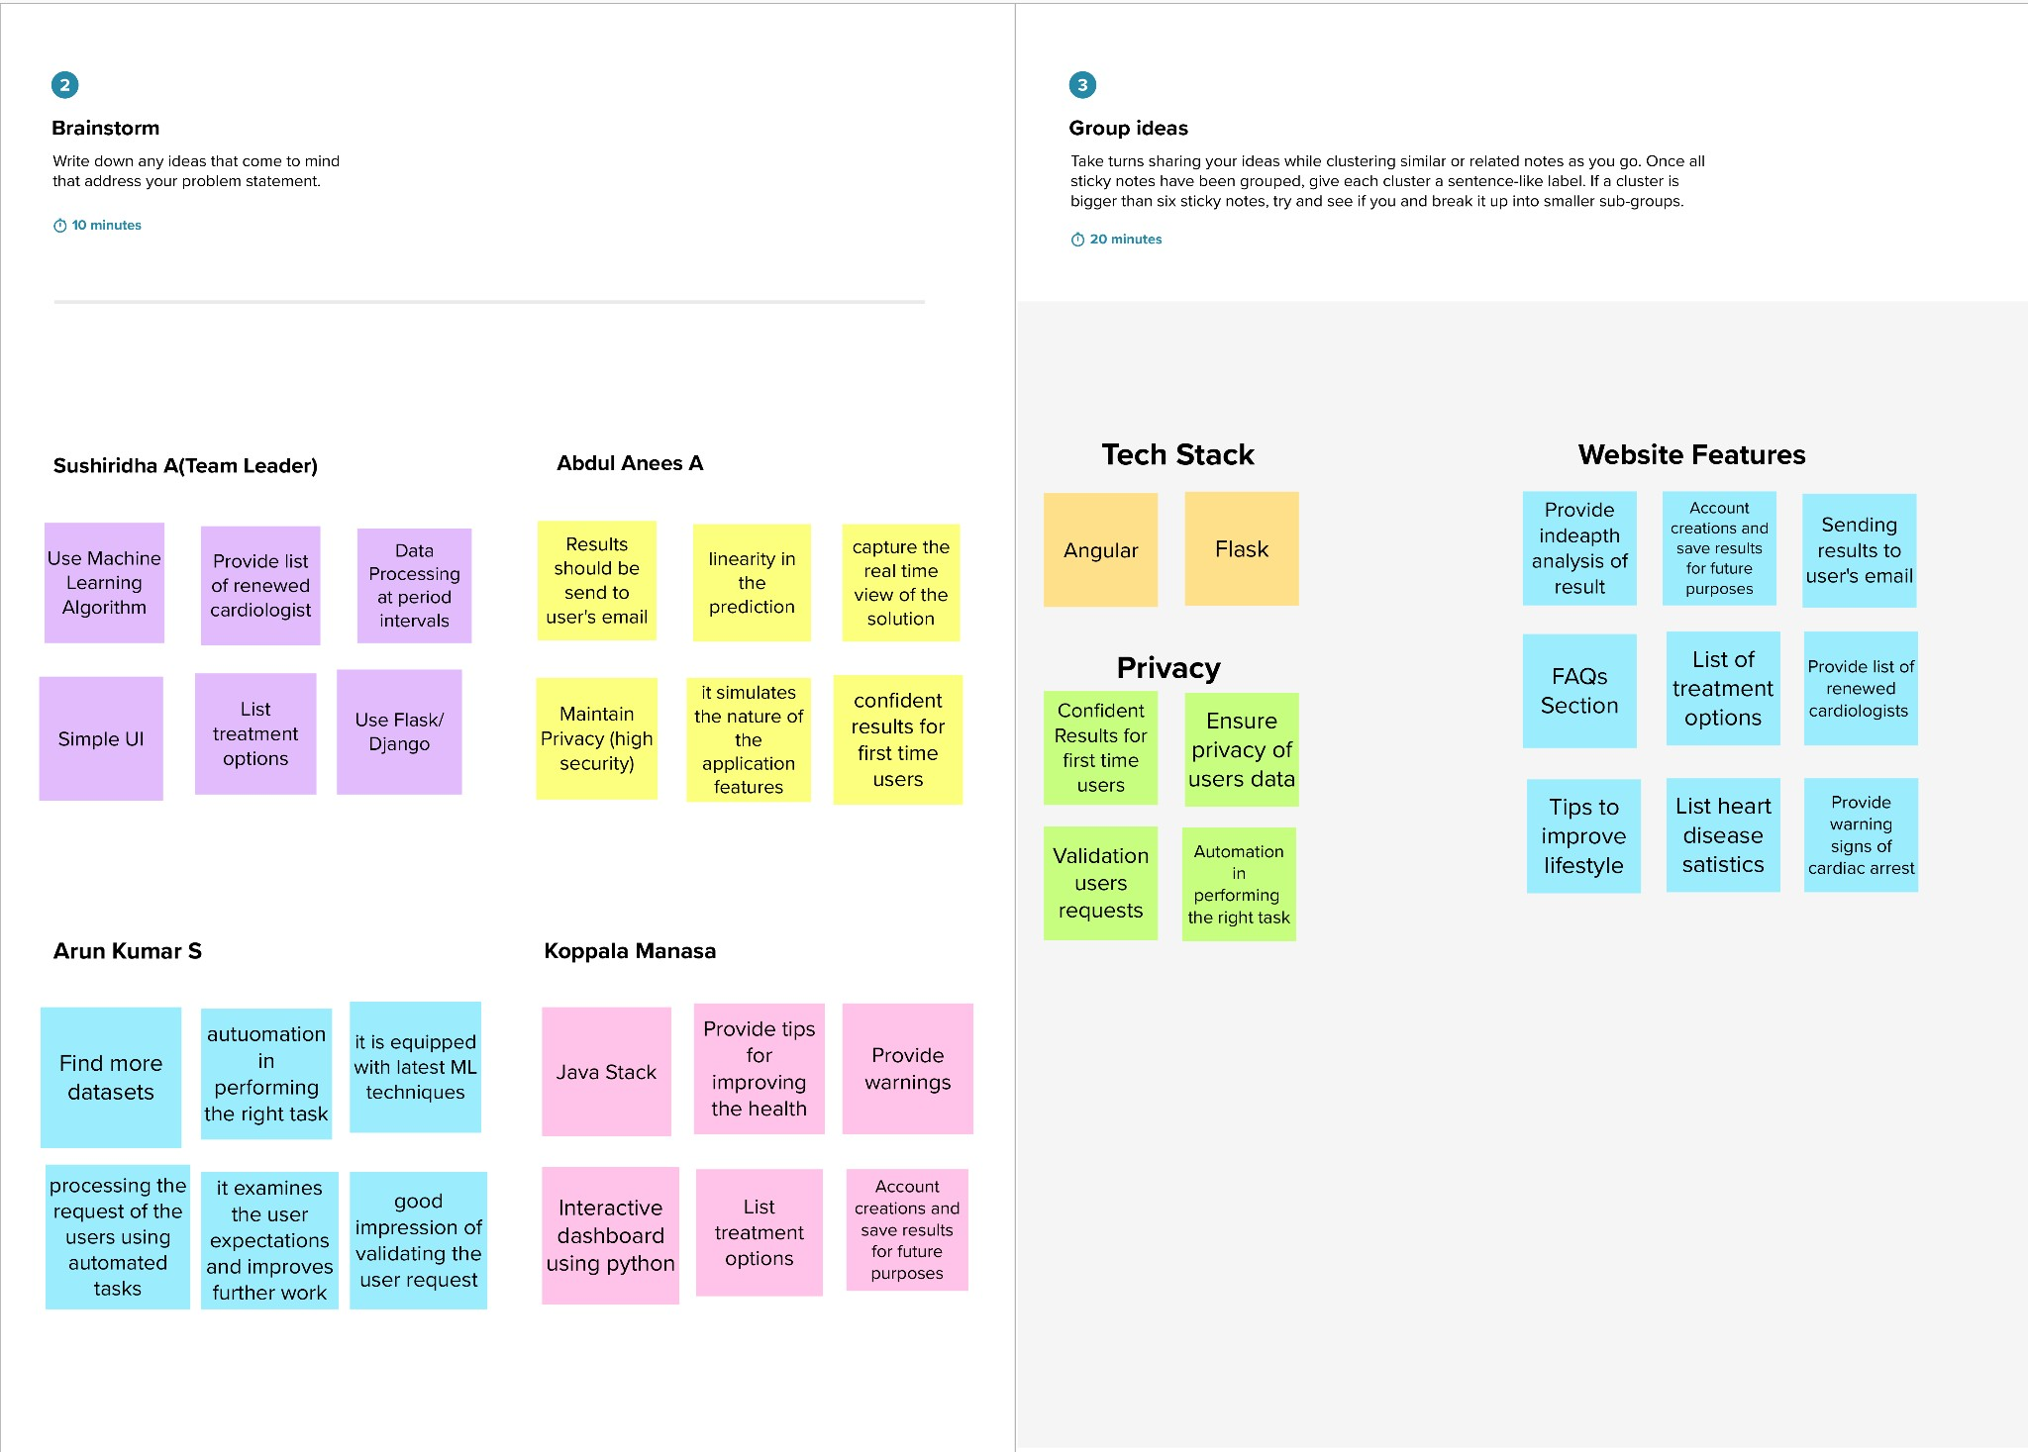

Step-3: Idea Prioritization

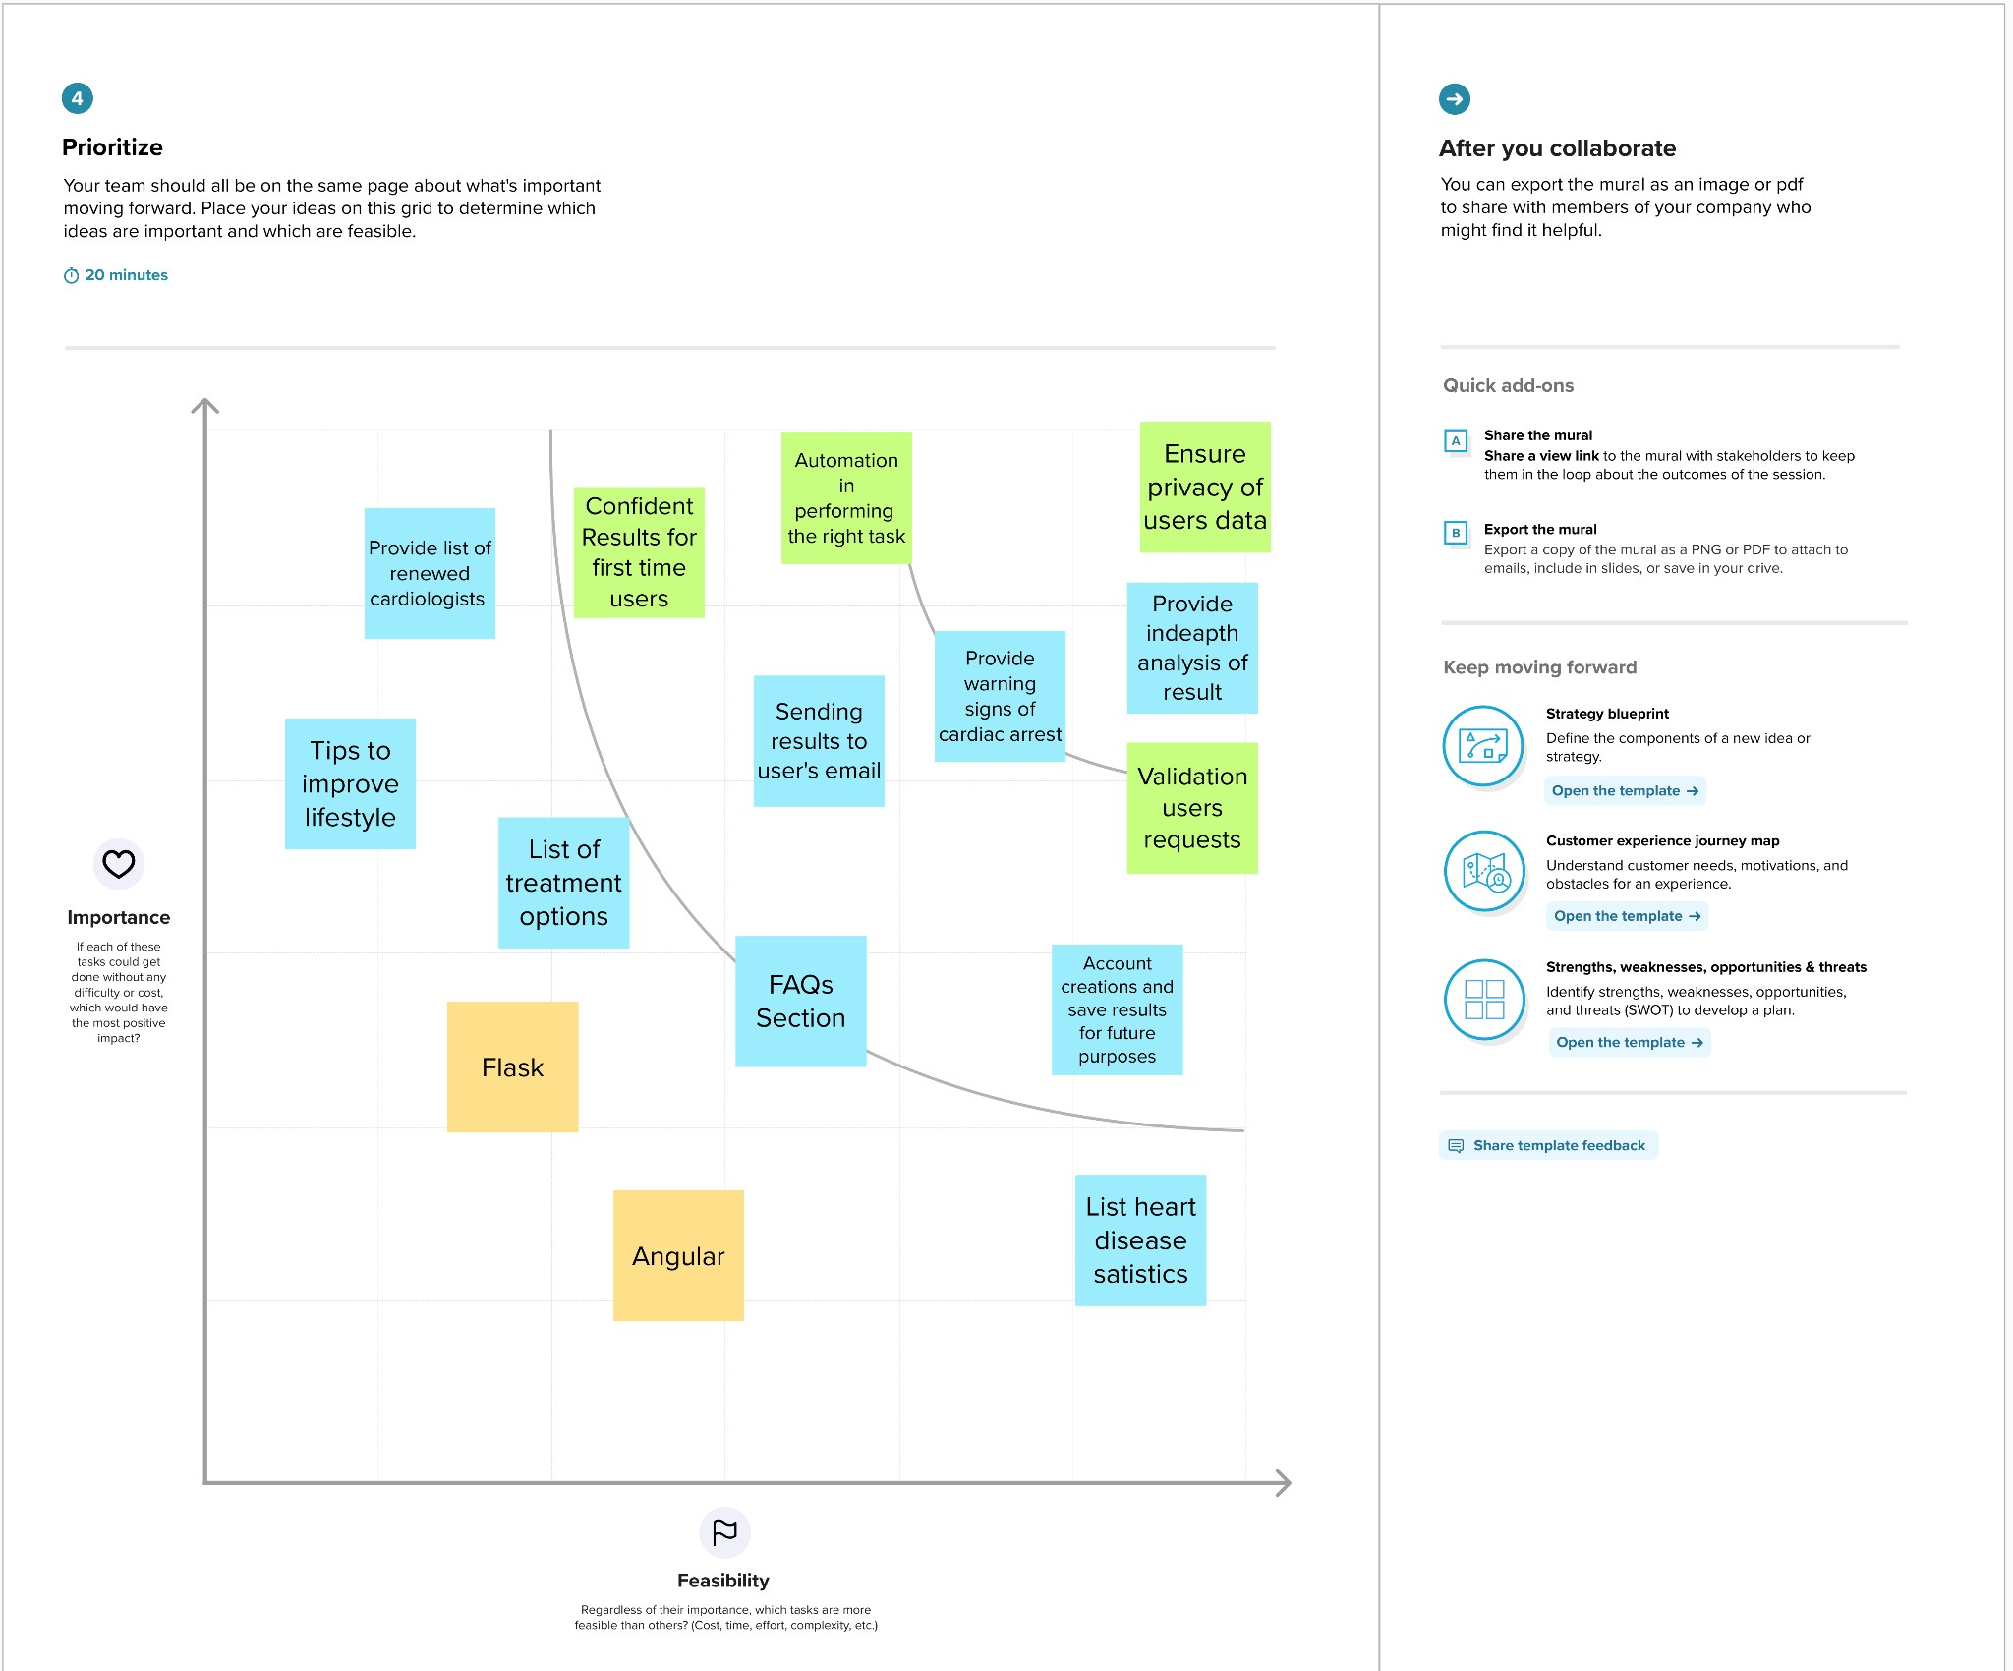

## Proposed Solution

|  |  |  |
| --- | --- | --- |
| **S.No.** | **Parameter** | **Description** |
| 1. | Problem Statement (Problem to be solved) | The leading cause of death in the developed world is heart disease. As a result, work must be done to reduce the risks of having a heart attack or stroke. It is infeasible for a common man to frequently undergo tests for ECG and so on. Hence , it requires a  replacement that is both convenient and dependable. |
| 2. | Idea / Solution description | The proposed solution proposes an interactive dashboard for visualizing and forecasting heart disorders, in which the user may observe his/her |

|  |  |  |
| --- | --- | --- |
|  |  | medical report analysis as well as the projected end result. IBM Cognos will be used to create the dashboard. Machine learning Algorithms will be used  to forecast cardiac disease. |
| 3. | Novelty / Uniqueness | Makes recommendations to the user based on that person's medical analysis. |
| 4. | Social Impact / Customer Satisfaction | It helps with disease prediction at an early stage and frequently alerts the user to their current health status.Both the user and the doctor can benefit from the system's improved decision-making regarding cardiac disease |
| 5. | Business Model (Revenue Model) | Can be deployed by Hospitals or NFOs, so that it makes the analysis in a fast manner. |
| 6. | Scalability of the Solution | The solution can work effectively on long and small datasets. It can also be changed to predict various other diseases depending on the dataset |

* 1. **Problem Solution Fit**

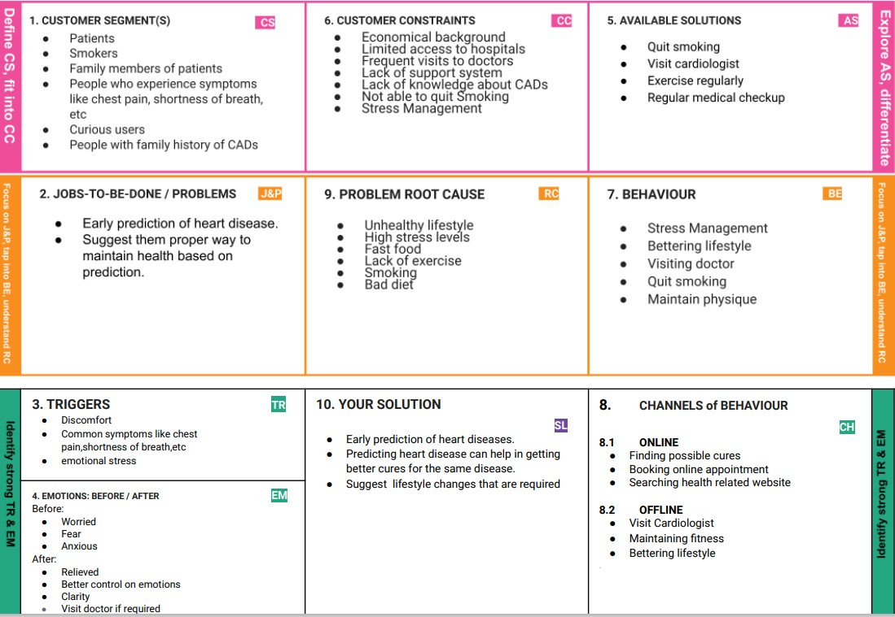

# Requirement Analysis

## Functional Requirement

Following are the functional requirements of the proposed solution.

|  |  |  |
| --- | --- | --- |
| **FR No.** | **Functional Requirement (Epic)** | **Sub Requirement (Story / Sub-Task)** |
| FR-1 | User Registration | Registration through Email |
| FR-2 | User Confirmation | Confirmation via Email |
| FR-3 | Visualizing Data | Visualize the trends on heart disease through  Dashboard created using IBM Cognos Analytics |
| FR-4 | Generation Report | Report can be viewed by the users |

## Non-Functional Requirement

Following are the non-functional requirements of the proposed solution.

|  |  |  |
| --- | --- | --- |
| **FR No.** | **Non-Functional Requirement** | **Description** |
| NFR-1 | **Usability** | Provide a simple UI.  Actions can be easily performed by a few clicks. Features will be understandable. |
| NFR-2 | **Security** | 2 step authorization (for register)  Have a backup dataset |
| NFR-3 | **Reliability** | Error must be low.(Improve accuracy) Must work without glitches |
| NFR-4 | **Performance** | It is affected by the implementing algorithm.  Depending on the error metrics we have to choose an algorithm with high response time. |
| NFR-5 | **Availability** | Must be available for the user 24 x 7 without interruptions |
| NFR-6 | **Scalability** | Should withstand a high number of users and large datasets. |

# Project Design

## Data Flow Diagram

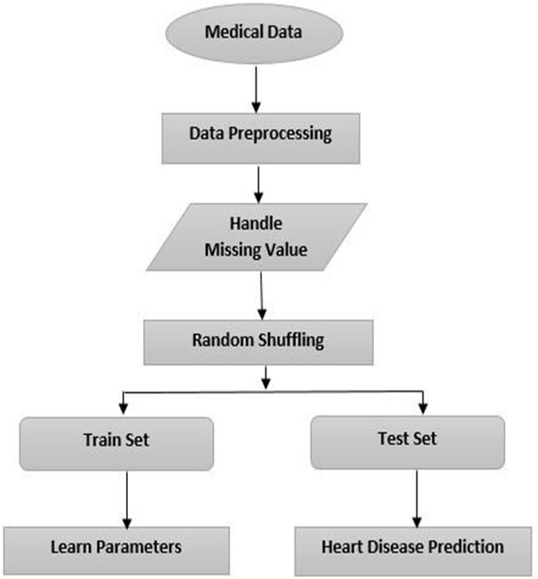

* 1. **Solution and Technical Architecture**

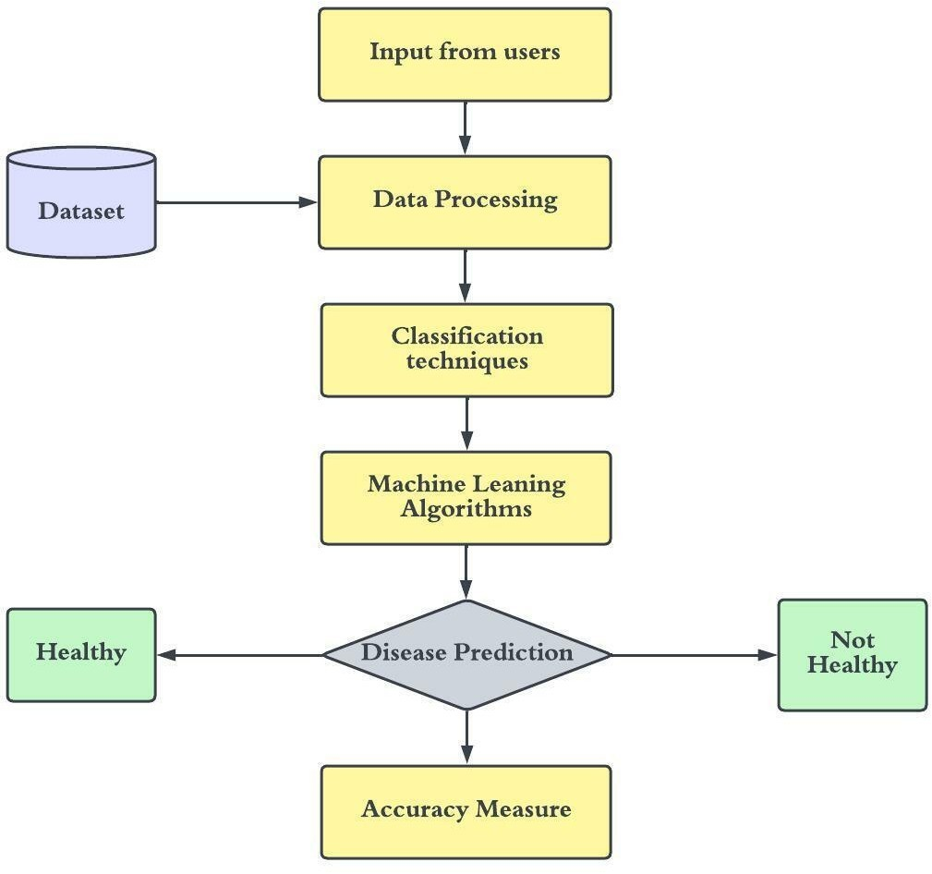

* 1. **User stories**

|  |  |  |  |  |  |
| --- | --- | --- | --- | --- | --- |
| **Sprint** | **Functional**  **Requirement (Epic)** | **User Story Number** | **User Story / Task** | **Story Points** | **Priority** |
| Sprint-1 | Registration | USN-1 | As a user, I can register for the application by  entering my email, password, and confirming my password. | 3 | High |
| Sprint-1 |  | USN-2 | As a user, I will receive confirmation email once I  have registered for the application | 3 | High |
| Sprint-1 |  | USN-3 | As a user, I can register for the application through  Gmail | 3 | Medium |
| Sprint-1 | Login | USN-4 | As a user, I can log into the application by entering  email & password | 6 | High |
| Sprint-2 | Dashboard | USN-5 | Attractive dashboard For the Application | 3 | Medium |
| Sprint-2 |  | USN-6 | Profile - view & update your profile | 5 | Low |
| Sprint-2 |  | USN-7 | Home - Analyze your Heart problem | 2 | High |
| Sprint-2 |  | USN-8 | The user will have to fill in the below 13 fields for the system to predict a disease  -Age in year -Gender  -Chest pain Type  -Fasting Blood Sugar  -Resting Electrographic Results  -Exercise Induced Angina  -Trust Blood Pressure | 7 | High |
| Sprint-3 | Support | USN-9 | Get feedback from users | 10 | Medium |
| Sprint-3 |  | USN-10 | Responds to user queries via telephone,email etc. | 3 | Medium |
| Sprint-3 |  | USN-11 | The team must respond immediately to the queries based on the priority | 5 | High |
| Sprint-4 | System  Requirements | USN-12 | Hardware Requirement  1. Laptop or PC   * i5 processor system or higher * 4 GB RAM or higher * 128 GB ROM or higher   2. Mobile   * (12.0 and above) | 5 | Low |
| Sprint-4 |  | USN-13 | Software Requirement  1. Laptop or PC   * Windows 10 or higher * Android Studio | 8 | Medium |

# Project Planning and Scheduling

## Script Planning and Execution

|  |  |  |  |  |  |  |
| --- | --- | --- | --- | --- | --- | --- |
| **Sprint** | **Functional**  **Requirement (Epic)** | **User Story Number** | **User Story / Task** | **Story Points** | **Priority** | **Team**  **Members** |
| Sprint-1 | Registration | USN-1 | As a user, I can register for the application by entering my email, password, and confirming my  password. | 3 | High | 1 |
| Sprint-1 |  | USN-2 | As a user, I will receive confirmation email once I have registered for the  application | 3 | High | 3 |
| Sprint-1 |  | USN-3 | As a user, I can register for the application through Gmail | 3 | Medium | 1 |
| Sprint-1 | Login | USN-4 | As a user, I can log into the application by entering email &  password | 6 | High | 5 |
| Sprint-2 | Dashboard | USN-5 | Attractive dashboard For the  Application | 3 | Medium | 3 |
| Sprint-2 |  | USN-6 | Profile - view & update your profile | 5 | Low | 2 |
| Sprint-2 |  | USN-7 | Home - Analyze your Heart problem | 2 | High | 4 |
| Sprint-2 |  | USN-8 | The user will have to fill in the below 13 fields for the system to predict a disease  -Age in year -Gender  -Chest pain Type  -Fasting Blood Sugar  -Resting Electrographic Results  -Exercise Induced Angina  -Trust Blood Pressure | 7 | High | 2 |
| Sprint-3 | Support | USN-9 | Get feedback from users | 10 | Medium | 3 |
| Sprint-3 |  | USN-10 | Responds to user queries via telephone,email etc. | 3 | Medium | 2 |
| Sprint-3 |  | USN-11 | The team must respond immediately  to the queries based on the priority | 5 | High | 5 |
| Sprint-4 | System  Requirements | USN-12 | Hardware Requirement  3. Laptop or PC   * i5 processor system or higher * 4 GB RAM or higher * 128 GB ROM or higher   4. Mobile   * (12.0 and above) | 5 | Low | 2 |
| Sprint-4 |  | USN-13 | Software Requirement  2. Laptop or PC | 8 | Medium | 4 |

|  |  |  |  |  |  |  |
| --- | --- | --- | --- | --- | --- | --- |
|  |  |  | * Windows 10 or higher * Android Studio |  |  |  |

* 1. **Sprint Delivery Schedule**

|  |  |  |  |  |  |  |
| --- | --- | --- | --- | --- | --- | --- |
| **Sprint** | **Total Story Points** | **Duration** | **Sprint Start Date** | **Sprint End Date (Planned)** | **Story Points**  **Completed (as on Planned End Date)** | **Sprint Release Date (Actual)** |
| Sprint-1 | 20 | 6 Days | 24 Oct 2022 | 29 Oct 2022 | 20 | 29 Oct 2022 |
| Sprint-2 | 20 | 6 Days | 30 Oct 2022 | 04 Nov 2022 | 17 | 04 Nov 2022 |
| Sprint-3 | 20 | 6 Days | 05 Nov 2022 | 11 Nov 2022 | 18 | 11 Nov 2022 |
| Sprint-4 | 20 | 6 Days | 12 Nov 2022 | 17 Nov 2022 | 19 | 17 Nov 2022 |

* 1. **Jira Report**

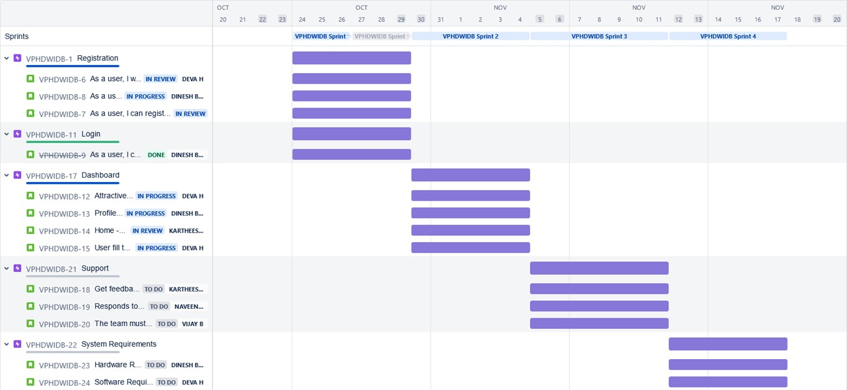

# Coding And Solutioning

## Machine Learning

Learning which model is best for the given Dataset

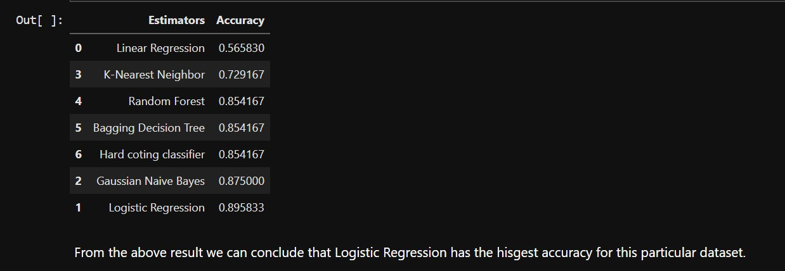

Comparing it with the accuracy gotten from Decision Tree:

*TP=cm[0][0] #cm=Confusion Matrix TN=cm[1][1]*

*FN=cm[1][0]*

*FP=cm[0][1]*

*print('Testing Accuracy for Decision Tree:',(TP+TN)/(TP+TN+FN+FP)) print('Testing Sensitivity for Decision Tree:',(TP/(TP+FN))) print('Testing Specificity for Decision Tree:',(TN/(TN+FP))) print('Testing Precision for Decision Tree:',(TP/(TP+FP)))*



## Dashboard

Age By Chest Pain type comparison.

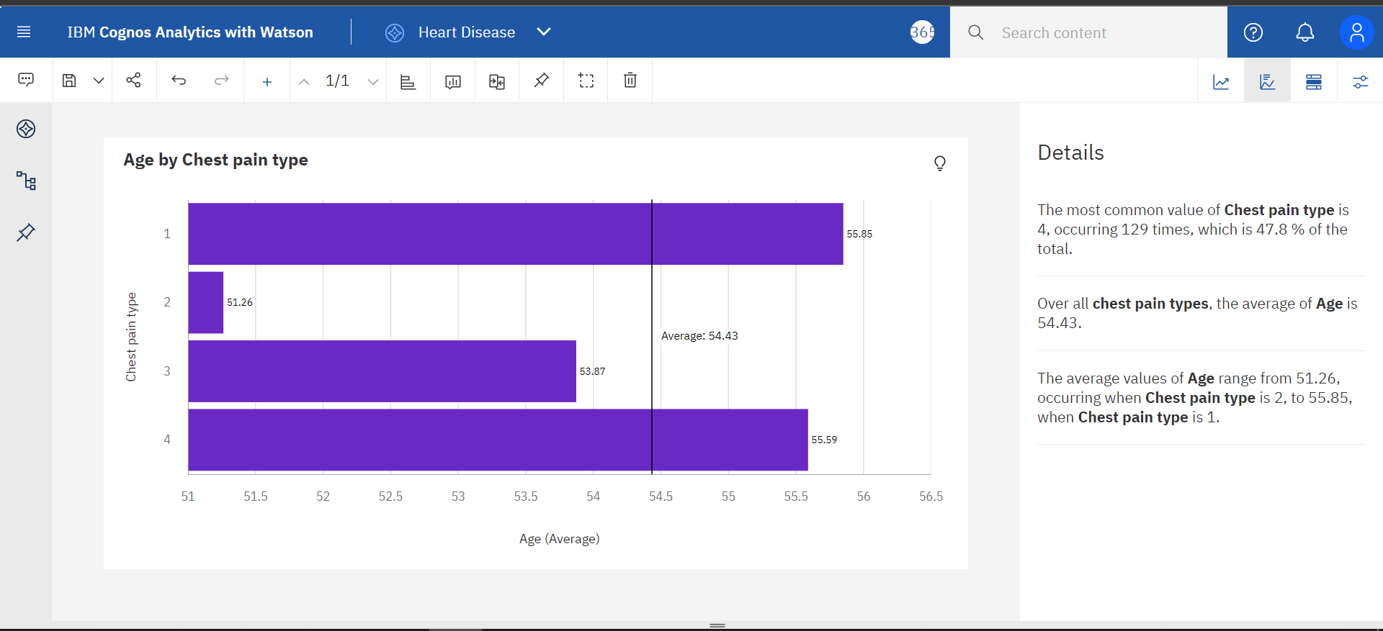

Exploration Of BPvsChestPainType And Gender:

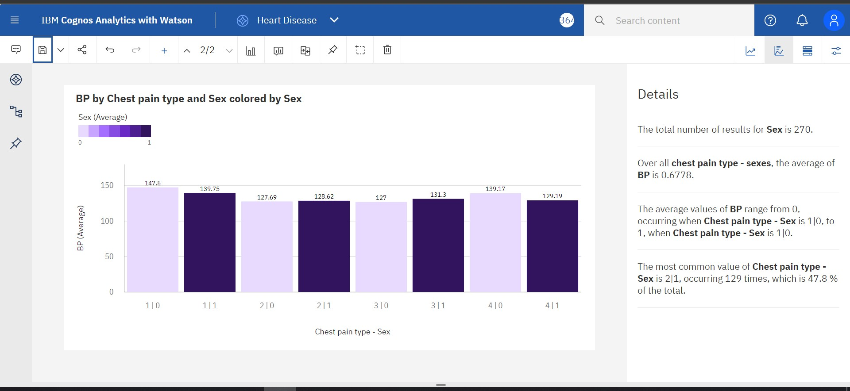

Exploration Of Max Heart Rate During The Chest Pain:

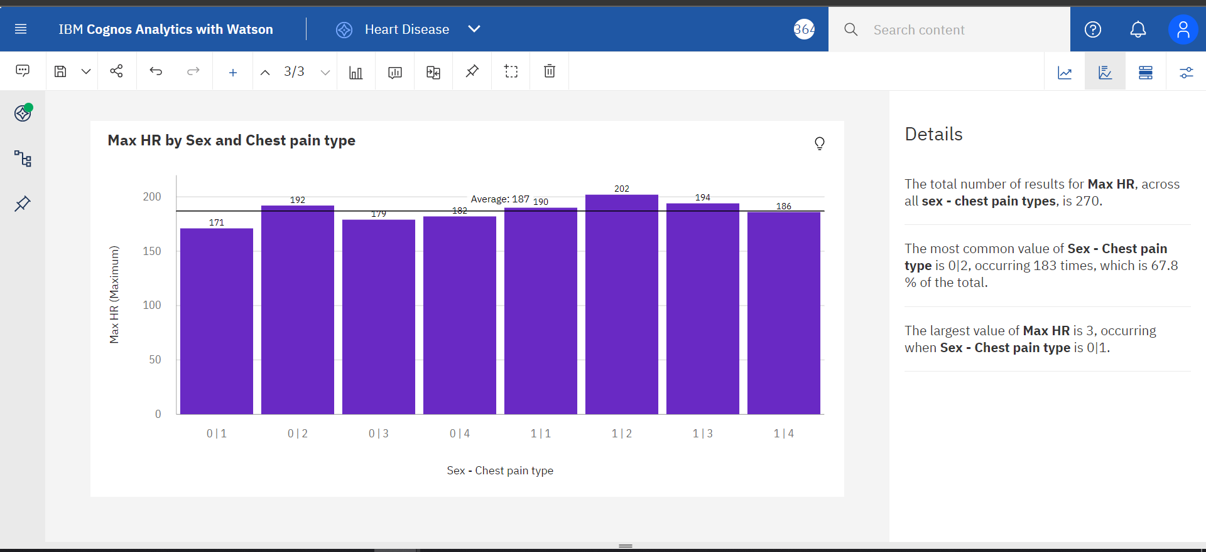

Exploration Of BP By Age:

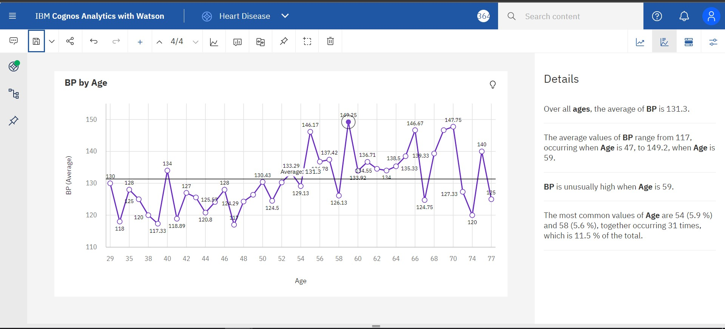

**Dashboard Showing Different Types Of Visuals:**

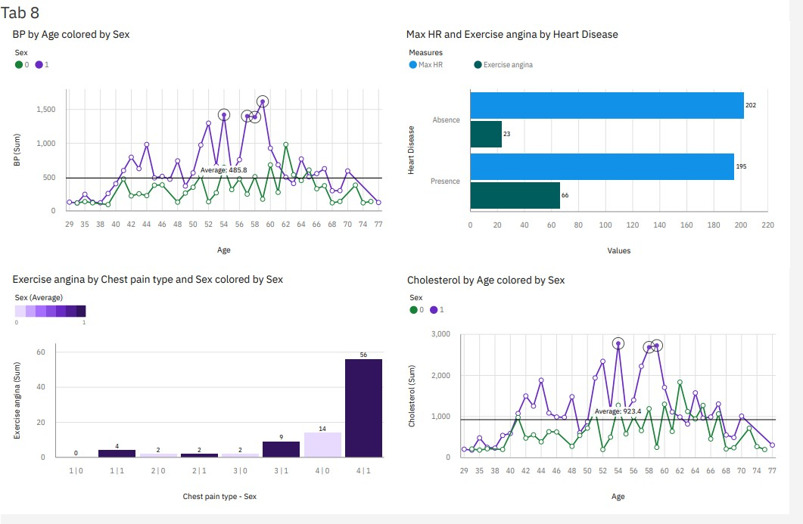

# Testing

## Test Cases

Testing the data model for various input values.

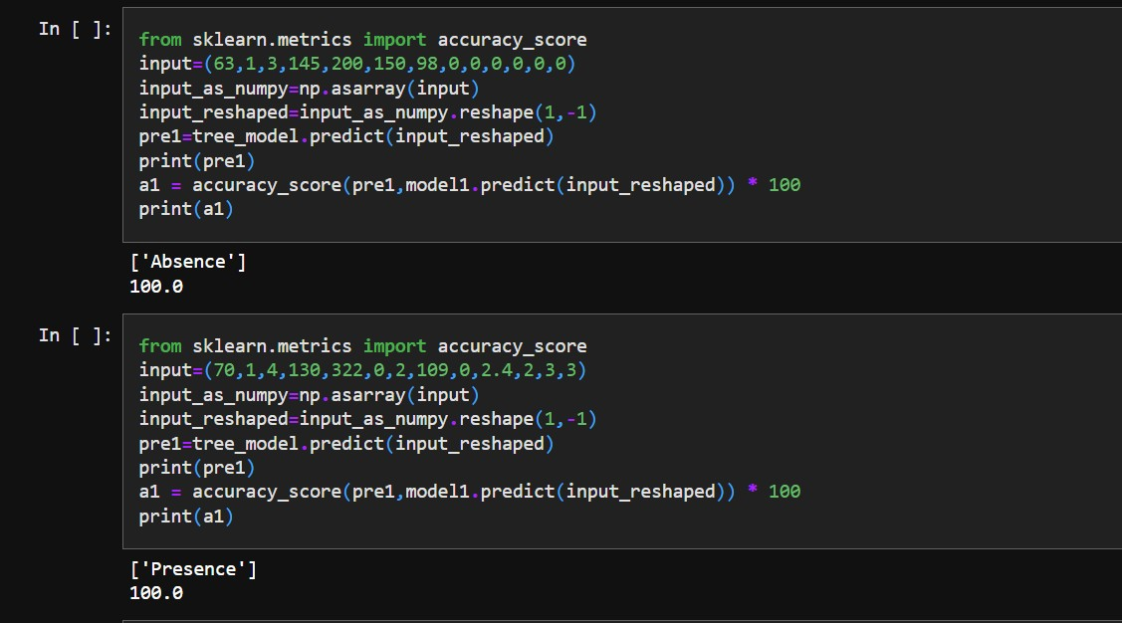

## User acceptance Testing

Testing a case where user has heart disease

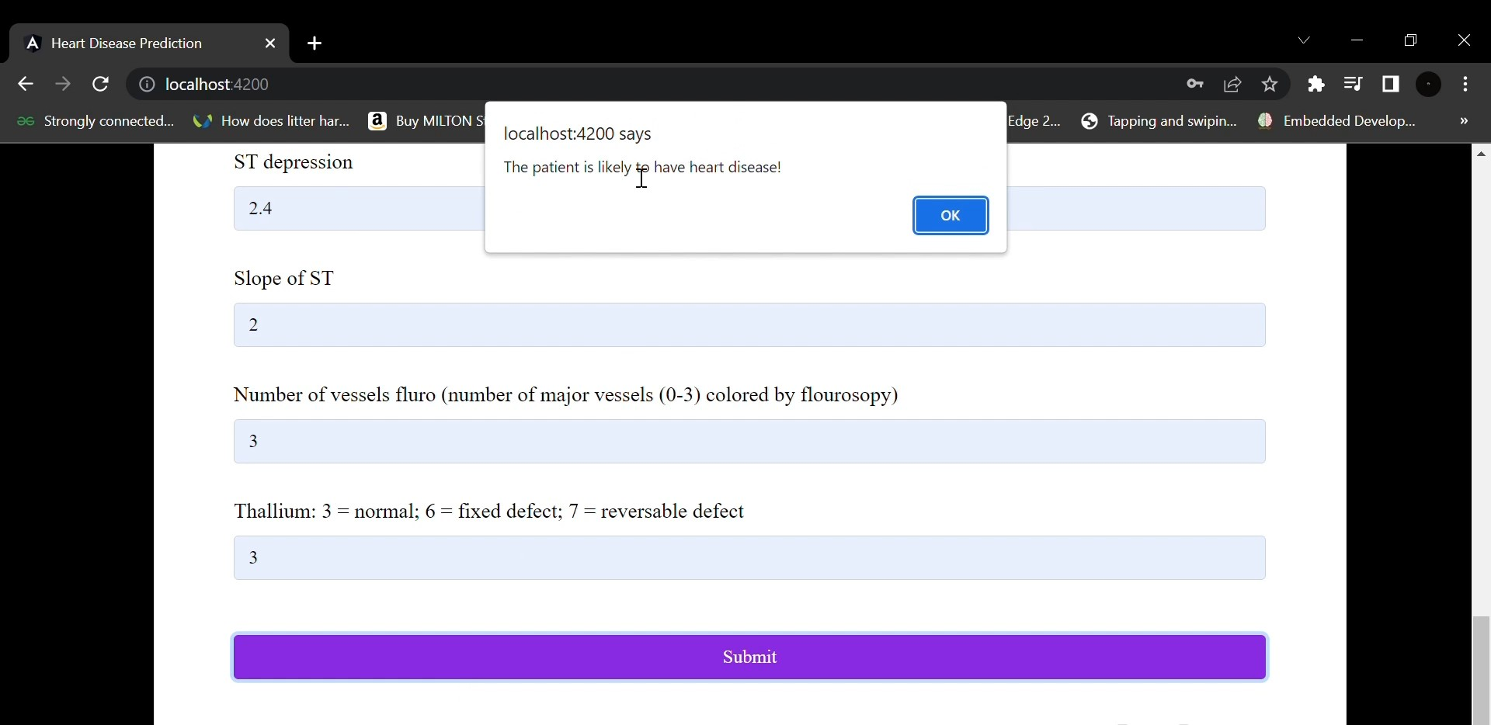

Testing a case where user does not have heart disease

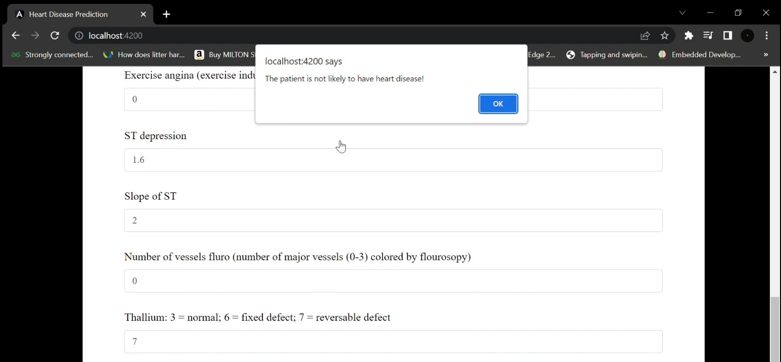

# Result

## Performance Metrics

The confusion matrix below shows the performance metrics of the machine learning model.

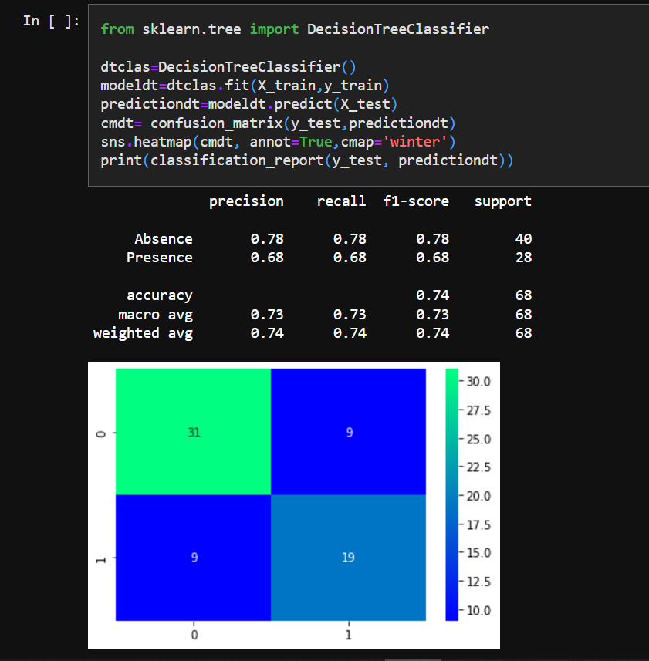

# Advantages Disadvantages

## Advantages:

* This is one of the fastest ways to determine if a person is likely to suffer from a heart disease or not.
* Useful for medical practitioners to easily classify their patients.
* User Friendly
* Easy to understand
* Secure
* Dashboard provides insightful informations

## Disadvantages:

* Needs work
* Users need to know all the fields
* Does Not take null value as input
* Does not provide suggestions to user

# Conclusion

Complications of heart disease include heart attack and stroke. You can reduce the risk of complications with early diagnosis and treatment. So the suggestion that we get from the website might help save patients. It is always to get treated in the early stages of heart disease.

1. **Future Scope**

Like the saying goes “Prevention is better than cure”. We have to look into methods to prevent heart diseases altogether other than just predicting it in early stages.

To use this website we need to take a lot of tests beforehand. So it would be better if we require less attributes and still give an effective result

1. **Appendix**

Source Code: https://github.com/[IBM-EPBL](https://github.com/IBM-EPBL)/[**IBM-Project-43902-1660720465**](https://github.com/IBM-EPBL/IBM-Project-43902-1660720465)

DemoLink:<https://drive.google.com/file/d/1lHbyZX-m5QuCelnYKjTOctIHe-X-dFHp/view?usp=share_link>